DSA06 DATA HANDLING AND VISUALIZATION | Activity: Correlation Detective | Slot D
R.No: 26 Reg. No: 192424308 Name: MUNGAMURU TEJA KUMAR
Time: 20 to 25 minutes Total: 20 marks Tool: R (ggplot2 / base R). Work alone; your case file is different from your neighbour's. Write your answers and paste your plots and code.
Case File CD-D26: The Online store Case [20 marks]
Briefing: 14 weekly records from the festive quarter, seven variables. Some relationships can be trusted; others are traps: a hidden driver, a curve that fools r, and a single wrong record.
Evidence: the case file (generated with the given code, set.seed(22505), not edited)
set.seed(22505)
n <- 14
festive_index <- round(rnorm(n, 61.4, 16.3), 1)
ad_clicks <- round(89.3 + 21.8 * (0.89 * (festive_index - 61.4) / 16.3 + 0.46 * rnorm(n)), 1)
parcels <- round(67.0 + 16.3 * (0.87 * (festive_index - 61.4) / 16.3 + 0.49 * rnorm(n)), 1)
delay_dev <- round(seq(-19.6, 19.6, length.out = n)[order(runif(n))], 1)
complaints <- round(11.2 + 35.3 * (delay_dev / 19.6)^2 + rnorm(n, 0, 1.6), 0)
staff_online <- round(rnorm(n, 17, 4.4), 0)
returns <- round(28 + 8.7 * (0.06 * (staff_online - 17) / 4.4 + 1.00 * rnorm(n)), 0)
staff_online[5] <- 31; returns[5] <- 55 # row 5 was typed in by a trainee
case <- data.frame(festive_index, ad_clicks, parcels, delay_dev, complaints, staff_online, returns)

Row | festive_index | ad_clicks | parcels | delay_dev | complaints | staff_online | returns
1 | 63.1 | 89.9 | 64.0 | -10.6 | 22 | 18 | 32
2 | 87.6 | 121.6 | 78.9 | -4.5 | 17 | 13 | 24
3 | 97.6 | 107.2 | 108.2 | -16.6 | 34 | 23 | 29
4 | 76.3 | 105.9 | 79.5 | 13.6 | 31 | 15 | 24
5 | 81.6 | 112.4 | 89.7 | 1.5 | 15 | 31 | 55
6 | 94.7 | 132.8 | 95.6 | 10.6 | 22 | 19 | 33
7 | 64.7 | 103.1 | 82.4 | -7.5 | 17 | 18 | 22
8 | 92.5 | 141.1 | 92.0 | 7.5 | 17 | 17 | 14
9 | 60.8 | 65.2 | 69.2 | 16.6 | 37 | 20 | 26
10 | 55.7 | 74.3 | 70.0 | 4.5 | 13 | 16 | 15
11 | 45.1 | 60.4 | 55.3 | -1.5 | 11 | 14 | 30
12 | 93.1 | 111.9 | 93.3 | 19.6 | 45 | 18 | 26
13 | 64.4 | 84.0 | 74.8 | -19.6 | 45 | 20 | 25
14 | 76.6 | 130.0 | 90.9 | -13.6 | 28 | 13 | 33
Key competency: correlation matrix, correlogram, nonlinear relationship, outlier influence, confounding and partial correlation
1. The matrix. Use cor(case) to get the 7 x 7 correlation matrix (round to 2 decimals). State n and how many distinct pairs of variables there are. Draw a correlogram of the matrix. [4]
cm <- round(cor(case), 2)
cm
nrow(case) # n = 14
choose(7, 2) # 21 distinct pairs

library(ggplot2); library(reshape2)
ggplot(melt(cm), aes(Var1, Var2, fill = value)) +
geom_tile(colour = "white") +
geom_text(aes(label = sprintf("%.2f", value)), size = 3) +
scale_fill_gradient2(low = "red", mid = "white", high = "blue", limits = c(-1, 1)) +
labs(x = NULL, y = NULL, fill = "r", title = "Correlogram of the case file") +
theme_minimal() + theme(axis.text.x = element_text(angle = 45, hjust = 1))

 | festive_index | ad_clicks | parcels | delay_dev | complaints | staff_online | returns
festive_index | 1.00 | 0.85 | 0.90 | 0.15 | 0.24 | 0.23 | 0.11
ad_clicks | 0.85 | 1.00 | 0.77 | 0.03 | -0.05 | 0.01 | 0.08
parcels | 0.90 | 0.77 | 1.00 | -0.01 | 0.27 | 0.35 | 0.15
delay_dev | 0.15 | 0.03 | -0.01 | 1.00 | 0.04 | -0.03 | -0.13
complaints | 0.24 | -0.05 | 0.27 | 0.04 | 1.00 | 0.10 | -0.07
staff_online | 0.23 | 0.01 | 0.35 | -0.03 | 0.10 | 1.00 | 0.66
returns | 0.11 | 0.08 | 0.15 | -0.13 | -0.07 | 0.66 | 1.00
n = 14 weekly records. Number of distinct pairs of 7 variables = 7 x 6 / 2 = 21 (the matrix has 49 cells: 7 on the diagonal equal to 1 and 42 off-diagonal cells, which repeat each pair twice).
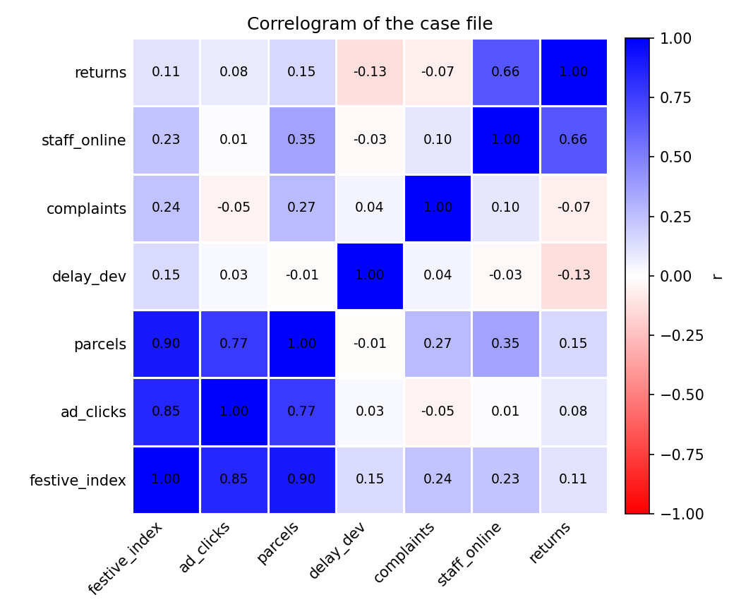
Correlogram of the case file (blue = positive, red = negative)
2. The strongest clues. Name the strongest positive pair and the strongest negative pair (off-diagonal). Give r for each and call it weak (below 0.3), moderate (0.3 to 0.7) or strong (above 0.7). [3]
Strongest positive pair: festive_index and parcels, r = +0.90: strong (above 0.7). Busier festive weeks deliver more parcels. (Next: festive_index and ad_clicks, r = +0.85, and ad_clicks and parcels, r = +0.77, also strong.)
Strongest negative pair: delay_dev and returns, r = -0.13: weak (below 0.3 in size). No pair in this case file has a real negative link; the most negative values are all close to zero (delay_dev and returns -0.13, complaints and returns -0.07, ad_clicks and complaints -0.05), so the strongest negative is only noise.
3. The deceptive zero. Plot complaints against delay_dev with a straight line, then add a quadratic fit (formula = y ~ x + I(x^2)). Report r and the R-squared of the quadratic fit. In one sentence, say why r misses this relationship. [4]
ggplot(case, aes(delay_dev, complaints)) +
geom_point() +
geom_smooth(method = "lm", formula = y ~ x, se = FALSE, colour = "red") +
geom_smooth(method = "lm", formula = y ~ x + I(x^2), se = FALSE, colour = "blue") +
labs(x = "delay_dev (hours)", y = "complaints") + theme_minimal()

cor(case$delay_dev, case$complaints)
summary(lm(complaints ~ delay_dev + I(delay_dev^2), data = case))$r.squared

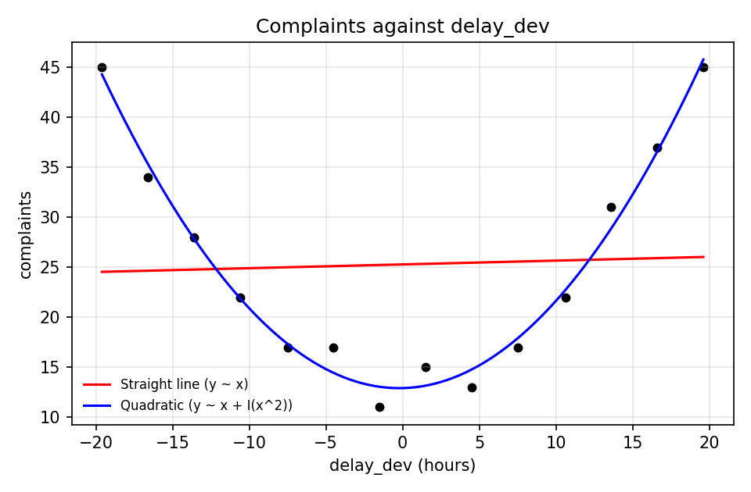
Complaints against delay_dev: straight line (red) and quadratic fit (blue)
r = 0.04 (essentially zero). Quadratic fit: complaints = 12.90 + 0.038 delay_dev + 0.0837 delay_dev^2, with R-squared = 0.985 (adjusted 0.982), so the curve explains about 98% of the variation.
Why r misses it: r measures only straight-line association, and this U-shaped relationship (complaints lowest when delivery is on time and rising for both early and late deliveries) has a falling left arm that cancels the rising right arm, so the straight-line slope is about zero.
4. The outlier alibi. Plot returns against staff_online. Find the row that looks wrong and give its row number. Report r for all rows and r without that row, and say what the single record did to r. [4]
ggplot(case, aes(staff_online, returns)) + geom_point() +
geom_smooth(method = "lm", se = FALSE) + theme_minimal()

which.max(case$returns) # 5
cor(case$staff_online, case$returns) # all rows
cor(case$staff_online[-5], case$returns[-5]) # without row 5

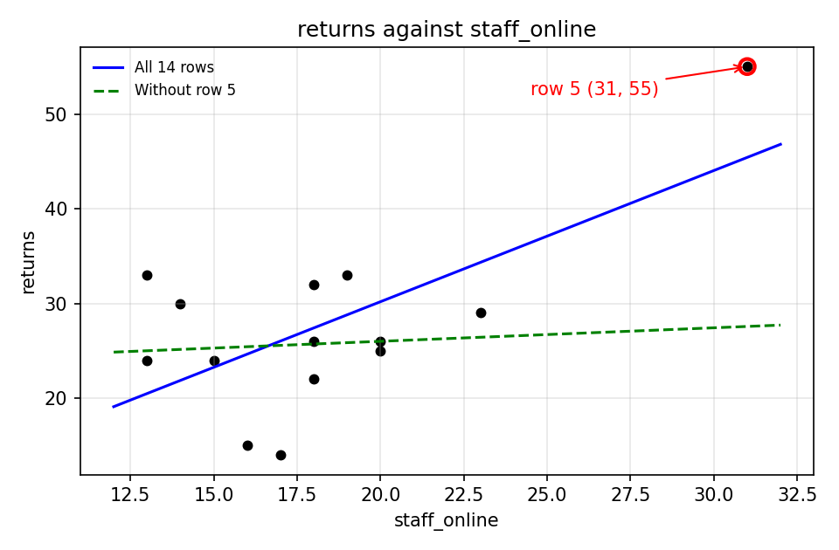
returns against staff_online; row 5 circled in red
The wrong-looking row is row 5: staff_online = 31 and returns = 55 (the trainee entry noted in the code). Every other week has 13 to 23 staff online (row 5 is 2.7 SDs above the mean) and 14 to 33 returns, so 55 is far outside the rest.
r with all 14 rows = 0.66 (moderate, near the strong cut-off). r without row 5 = 0.07 (weak). The single record inflated r by about 0.59: one wrong point created an apparent relationship that does not exist in the other 13 weeks.
5. The prime suspect. ad_clicks and parcels are strongly linked. Report r(ad_clicks, parcels), then r(festive_index, ad_clicks) and r(festive_index, parcels). Compute the partial correlation of ad_clicks and parcels controlling for festive_index: correlate resid(lm(ad_clicks ~ festive_index)) with resid(lm(parcels ~ festive_index)). Write a two-sentence verdict: does ad_clicks cause parcels? Name one study design that could test causation. [5]
cor(case$ad_clicks, case$parcels)
cor(case$festive_index, case$ad_clicks)
cor(case$festive_index, case$parcels)

r1 <- resid(lm(ad_clicks ~ festive_index, data = case))
r2 <- resid(lm(parcels ~ festive_index, data = case))
cor(r1, r2) # partial correlation

Correlation | r | Comment
r(ad_clicks, parcels) | +0.77 | strong
r(festive_index, ad_clicks) | +0.85 | strong
r(festive_index, parcels) | +0.90 | strong
Partial r(ad_clicks, parcels | festive_index) | +0.04 | about zero (p = 0.90)
Check by formula: (0.768 - 0.845 x 0.898) / sqrt((1 - 0.845^2)(1 - 0.898^2)) = (0.768 - 0.760) / sqrt(0.286 x 0.193) = 0.009 / 0.235 = 0.04.
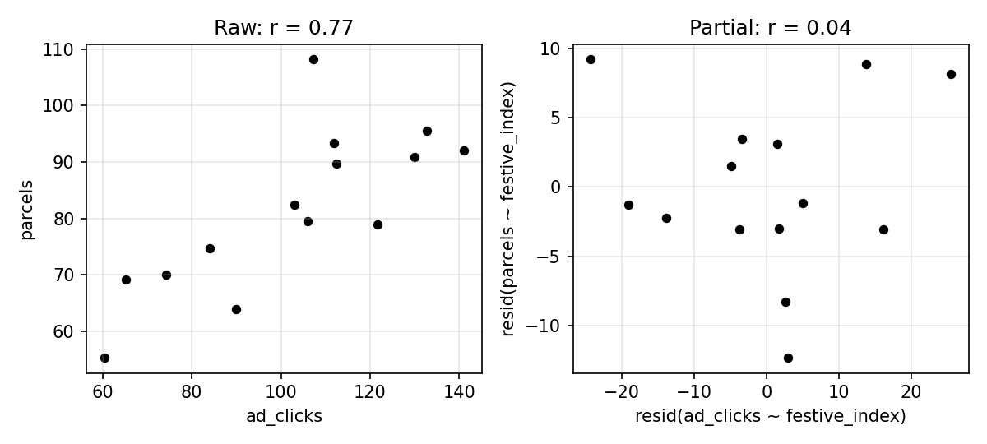
Left: raw ad_clicks vs parcels. Right: the same after removing festive_index (the link vanishes)
Verdict: ad_clicks and parcels are strongly linked (r = 0.77), but once festive_index is held constant the link disappears (partial r = 0.04), so the festive season is the hidden driver of both and ad clicks do not cause parcels. Correlation alone never proves causation.
Study design to test causation: a randomised controlled experiment (A/B test) in which, in comparable weeks or for randomly chosen customer groups, advert exposure is randomly switched on or off and parcels delivered are then compared between the two groups.
Detective's rule: correlation measures a straight-line link only, it can be inflated by one point, and it never proves cause.
Code of Conduct: I certify that this work is my own. Signature: ____________________

